**Screenshots of output**

1. **Basic Select Query:**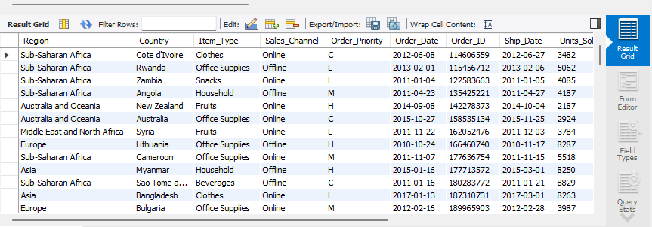
2. **Profit by Region:**

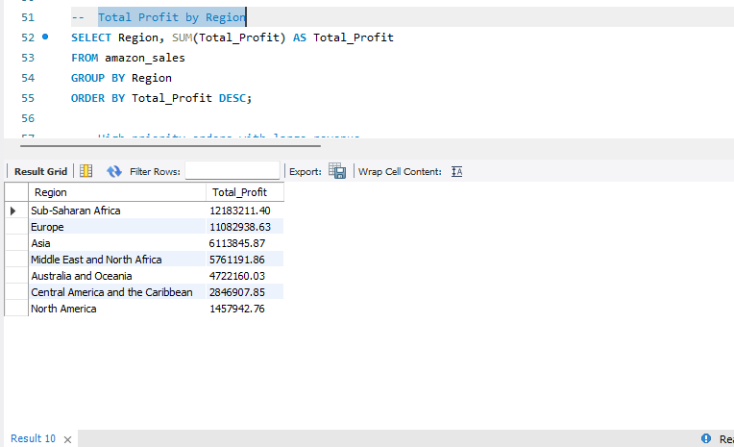

1. **High priority orders with large revenue:**

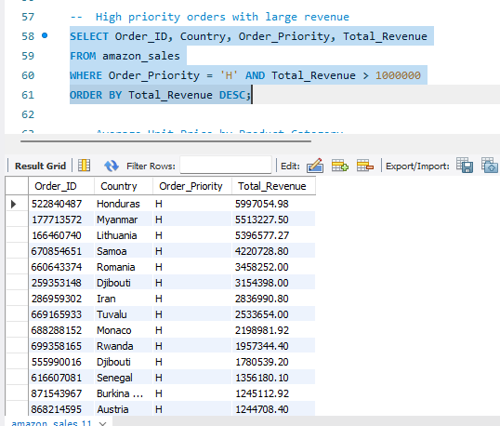

1. **Average Unit Price by Product Category:**

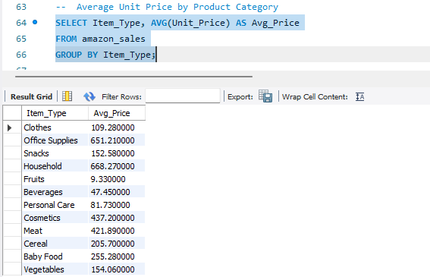

1. **Subquery: Countries with above-average total revenue:**

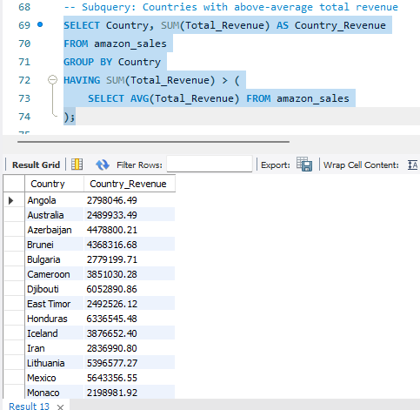

1. **JOIN: Sales with region manager details:**

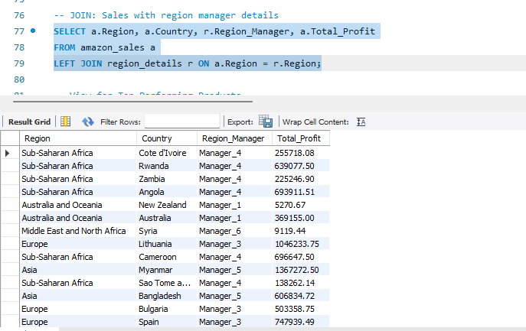

1. **Querying the created view:**

